📘 **SQL Project Report: Windows Functions**

🎯 Objective

To demonstrates the use of **MySQL window functions** to evaluate student performance, focusing on:

Ranking students by their total scores using RANK()

Analyzing cumulative math scores using SUM() OVER()

These techniques are valuable for performance tracking and trend analysis across educational datasets.

1️⃣ Dataset Preparation

1.1 Table Creation

CREATE TABLE Students ( StudentID INT PRIMARY KEY, Name VARCHAR(50), MathScore INT, TotalScore INT );

1.2 Sample Data Insertion

INSERT INTO Students (StudentID, Name, MathScore, TotalScore) VALUES (1, 'Arjun', 78, 230), (2, 'Bhavna', 88, 255), (3, 'Chitra', 95, 255), (4, 'Dev', 65, 200), (5, 'Esha', 85, 240);

OUTPUT:

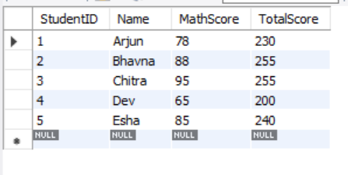

2️⃣ Analysis Tasks

Task 1: Rank Students Based on Total Scores

Assign a rank to each student using the RANK() function in descending order of TotalScore.

SQL Query

SELECT StudentID, Name, TotalScore, RANK() OVER (ORDER BY TotalScore DESC) AS `Rank` FROM Students;

Explanation

RANK() OVER (ORDER BY TotalScore DESC) ranks the students from highest to lowest TotalScore.

Students with the same score receive the same rank.

The next rank is skipped, reflecting academic ranking systems (e.g., 1, 1, 3).

OUTPUT:

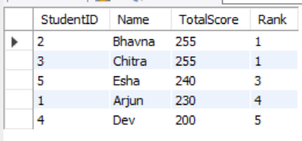

Output Description

Bhavna and Chitra receive **Rank 1** as they share the top score.

Esha follows at **Rank 3**, showing the skipped rank due to the tie.

Task 2: Calculate Running Totals for Math Scores

Calculate the cumulative total of MathScore based on StudentID order using SUM() OVER().

SQL Query

SELECT StudentID, Name, MathScore, SUM(MathScore) OVER (ORDER BY StudentID) AS RunningTotalMathScore FROM Students;

Explanation

SUM(MathScore) OVER (ORDER BY StudentID) adds scores progressively, sorted by StudentID.

It shows accumulated performance from the first student onward.

OUTPUT:

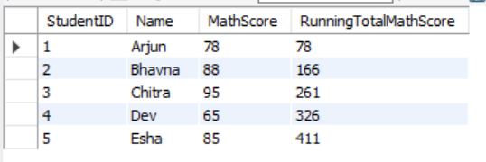

Description

Each row displays the running sum of MathScores, reflecting total contribution up to that point.

Useful for understanding academic momentum per entry.

3. Validation & Accuracy Checks

**Rank Results**

Confirm ranks align with descending TotalScore.

Check tied scores receive same rank and correct skipping behavior.

**Cumulative Totals**

Ensure running totals of MathScore are accurate by manual addition.

Confirm progressive growth across StudentIDs.

🔍 **Summary of Findings**

**Ranking**: Bhavna and Chitra tied at Rank 1 with the highest TotalScore (255), demonstrating how RANK() handles score ties and skips ranks appropriately.

**Cumulative Analysis**: The running total of MathScore showed progressive growth across StudentIDs using SUM() OVER().

**Insight**: Window functions like RANK() and SUM() offer efficient and insightful ways to track academic performance and data trends.